Quiz Practice Problems

Supply and Demand

1. Suppose a drought causes an increase in orange prices.
   1. What does this do to the equilibrium price and quantity of orange juice?

Oranges are a raw material for OJ. Price of oranges going up means that there will be a lower supply of OJ in the market. Therefore, the supply curve shifts to the left and the new equilibrium price is higher and the quantity is lower for OJ.

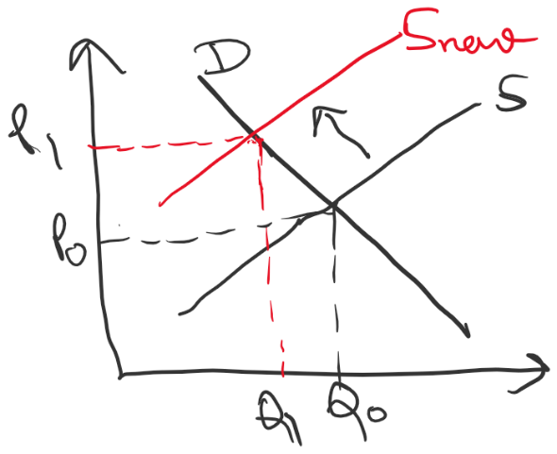

* 1. Suppose that apple juice is a substitute for orange juice. What impact does your answer in (a) have on the equilibrium price and quantity of apple juice?

Price of OJ, which is a substitute of apple juice going up means that fewer people will want OJ and they will move towards demanding more apple juice (increase in demand of apple juice). This will shift the demand curve of apple juice to the right. Both the price and the quantity demanded for apple juice will go up as a result.

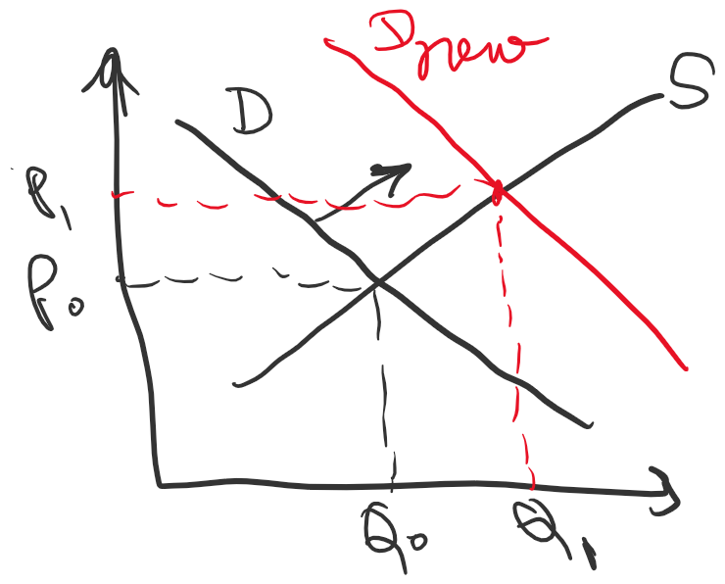

1. How would a Canadian government’s ban of caffeine in certain types of soda (such as used to be imposed Mountain Dew) impact the equilibrium price and quantity of coffee? (Increase, decrease, uncertain)

Let’s assume that coffee and caffeinated sodas are substitutes. A ban on caffeinated soda will increase the demand for coffee. The demand curve for coffee will shift to the right and the supply curve will be unaffected. Therefore, the **new equilibrium price and quantity for coffee will both increase.**

1. How would the same ban influence the producer surplus of coffee producers? (Increase, Decrease, Uncertain)

The producer surplus of coffee would go up since the new equilibrium price is higher.

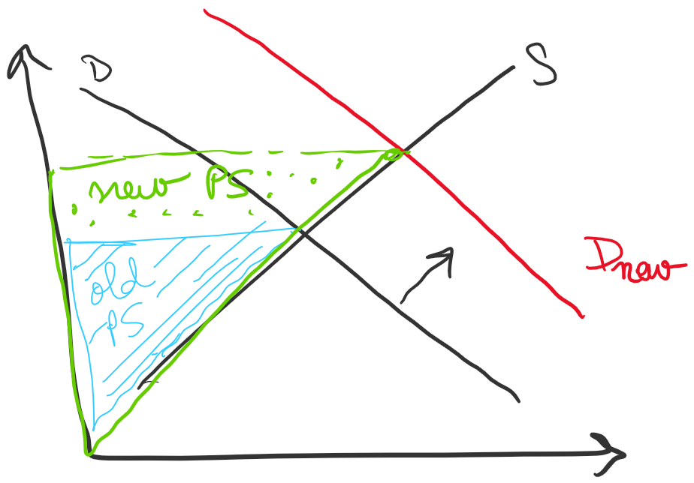

1. How does an increase in the price of coffee impact the quantity supplied of coffee? (Increase, decrease, no effect)

Increase in price **increases the quantity supplied** for coffee because of the upward sloping supply curve.

1. How does an increase in the price of coffee impact the supply of coffee? (Increase, decrease, no effect)

Increase in price of coffee has **NO EFFECT** on the overall supply of coffee. It only affects the quantity available in the market, which is determined by the existing supply curve. This is a trick question so watch-out.

1. Suppose the gasoline tax (paid by producers, i.e. included in the price) is increased by $.05/l. Which of the following statements are true, if demand slopes down and supply slopes up?
   1. Prices will rise by $.05
   2. Prices will rise by less than $.05 – TRUE, because the supply curve moves up by 0.05 so the price gain has to be less than 0.05 for a downward sloping demand curve.
   3. Prices will rise by more than $.05
   4. Fixing the supply curve, prices will rise by a greater amount the more inelastic is demand. – TRUE, the more inelastic the demand curve, the steeper it gets and the more the effect of the supply curve shifting up on the new equilibrium price is pronounced.
   5. None of the above
   6. More than one of the above – CORRECT ANSWER

Elasticity

1. The price elasticity of demand for cigarettes is estimated by the government to be -0.3. If the government imposes a tax that increases equilibrium prices by 15%, how would cigarette consumption change (direction and percent)?

The quantity demanded would **go down** by 0.3*15% = **4.5%**

**Given:**

$$E=-0.3,\frac{ΔP}{P}=+15\%=+0.15$$

**Formula:**

$$\frac{ΔQ}{Q}=E×\frac{ΔP}{P}$$

**Substitute:**

$$\frac{ΔQ}{Q}=(-0.3)(+0.15)=-0.045$$

**Convert to percent:**

$$-0.045×100=-4.5\%$$

✅ **Final Answer:**  
Cigarette consumption **decreases by 4.5%** when price **increases by 15**

1. A firm estimates its demand at Q=100-20p. What is the elasticity of demand if it produces 40 units? (Hint: Use q=40 as the quantity. To compute change in prices and quantities, you’ll need to choose another q; pick any one!)

At q=40, we can solve for p=3

Picking a different q now, q=50. We can solve for p=2.5

So, ΔQ/Q= (50-40)/40 = 1/4 and ΔP/P = (2.5-3)/3 = -1/6

**Elasticity = (1/4) / (-1/6) = -1.5**

1. For the example in (8), if price falls by a small amount, will revenues rise or fall?

Since the demand is elastic, the **revenue will rise** with a small fall in price (slide 16)

1. A firm estimates its demand at Q=100-20p. What is the elasticity of demand if it sets p=2? (Hint: Use p=2 as the price. To compute change in prices and quantities, you’ll need to choose another p; pick any one!)

At p=2, we can solve for Q=60

Setting p=3, we can solve for Q=40

So, ΔQ/Q = (40-60)/60 = -1/3 and ΔP/P = (3-2)/2 = 1/2

Therefore, **Elasticity = (-1/3) / (1/2) = -2/3 or -0.67**

1. For the example in (10), if price rises by a small amount, will revenues rise or fall?

Since the demand is inelastic, if price rises by a small amount, the **revenue will rise** (slide 16)

1. A firm estimates its demand has an elasticity of -0.5. It is currently producing 1000 units at a price of 10. About what price will it need to charge to sell 1100 units?

Here we can start by calculating the percent change in quantity:

ΔQ/Q = (1100-1000)/1000 = 10%

This lets us calculate the percent change in price needed = 10% / (-0.5) = -20%

So, the new price should be 20% lower than the current price, which means the **price should be 8.**

For answer- 9 and 11-

My explanation-

**🔹 Key idea: Total Revenue (TR) = Price (P) × Quantity (Q)**

When price changes, two forces work in **opposite directions**:

**Price effect:** Higher price tends to increase TR.

**Quantity effect:** Higher price reduces Q, which tends to decrease TR.

Elasticity tells us **which effect dominates**.

**1️⃣ Elastic region (|E| > 1) → Consumers are very responsive**

**If price ↑ (rises slightly):**  
Quantity demanded falls *more than proportionately*.  
→ The **quantity effect dominates**, so **TR decreases**.  
💡 *Example:* Coffee lovers easily switch to tea when price rises.

**If price ↓ (falls slightly):**  
Quantity demanded increases *more than proportionately*.  
→ The **quantity effect dominates again**, but in the positive direction — **TR increases**.  
💡 *Firms sell much more, and total earnings rise.*

**2️⃣ Inelastic region (|E| < 1) → Consumers are not very responsive**

**If price ↑ (rises slightly):**  
Quantity demanded falls *less than proportionately*.  
→ The **price effect dominates**, so **TR increases**.  
💡 *Think: Gasoline — price up, but people still buy it.*

**If price ↓ (falls slightly):**  
Quantity demanded rises *less than proportionately*.

**⚡ Quick Summary Table**

| **Elasticity Type** | **When Price ↑** | **When Price ↓** |
| --- | --- | --- |
| **Elastic (>1)** | **TR ↓** | **TR ↑** |
| **Inelastic (<1)** | **TR ↑** | **TR ↓** |
| **Unit Elastic (=1)** | **TR stays same** | **TR stays same** |

→ The **price effect dominates**, so **TR decreases**.  
💡 *You cut price, but people don’t buy that much more.*

**Quick Summary Table**

Elasticity TypeWhen Price ↑When Price ↓**Elastic (>1)**TR ↓TR ↑**Inelastic (<1)**TR ↑TR ↓**Unit Elastic (=1)**TR stays sameTR stays same

**My opinion:**  
Think of elasticity as a “sensitivity dial.” When demand is elastic, customers react a lot — so price changes backfire easily. When inelastic, they barely react — so firms can raise prices without much revenue loss.